Yaarub Talib Alyarubi

Bachelor of Engineering (Hons) Computer
Engineering (Cyber Security)
Experience:
FS store and Mtjr 4u:
- Fs store is an online market offering a wide range of products for retail Customers.
Instagram: @ Fs.store.om
- Mejr 4u is an online market offering Streaming and gaming products and services.
Instagram: a Mtir 4u Mandoob Al Fawaris:
- group of delivery heros by coordinating deliveries, accepting requests and charging a margin from each delivery request.
Food Truck:
Chef and Supervisor
- Responsible for the BBQ orders preparation and orders management.





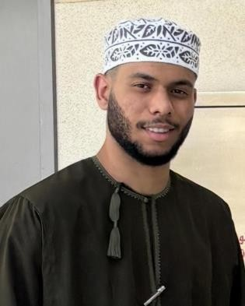
- Said Burger and digi digi mix.

+
968

77439114

Nationality
-

Omani

Date of Birth : 21/10/2000
yaarubalyarubi74@gmail.com

Al Mawaleh South, Muscat,
Sultanate of Oman

•

Arabic

•

English

Language:

Contact

Details:

Career Objective:
- Seeking a Job opportunity in a dynamic organization where I can utilize my skills in Cyber Security, Computer engineering and problem- solving Eager to apply academic Knowledge and gain hands on experience in network security, ethical hacking, and cyber threat management while contributing to the company's success.
Education:

- Bachelor of computer Engineering (cyber security).
Middle East College, muscat, Oman. ▪ Expected Graduation: 2026 ▪ Current GPA: 2.5.
- Relevant Courses: (Network security, cryptography, System Analysis, mal ware Analysis, cloud security).
- Diploma in computer Engineering(Cyber Security).
middle East college, muscat, Oman Completed: Jul 2024
- Relevant Courses: (Programming fundamentals) Networking Essentials, Database management.
Courses, Contributions and Achievements:
- Organizing mental Health Day Activities - Mazon Collage (Oct 2023).
- Basic First Aid CPR AED-NTI (Jul2023).
- Human Development Coaching session -AL Najah Academy for Human Development (April 2024).
Skills and Abilities:
- Cyber Security Tools: (Kali Linux, Ubuntu, Oracle, VM ware).
- program languages: (C++, Java, HTML /CSS, SQL).
- Operating Systems: (windows, Kali Linux, Ubuntu).
- Software: MS word, MS Excel, MS Power point, C++).
- Mature team worker with the ability to adapt to challenging Situations.

- Strong in collaborative environments and capable of working independently.
- Excellent problem-solving abilities and skilled in managing work under pressure to meet deadlines.
Hobbies and Interests:
- Playing football.
- Gym Fitness.
- Exploring New technological ideas.*
- Internet surfing and learning about cyber security Trends.
- Traveling and Exploring New Cultures.
References:
• Student Success Center: Badriya Al-Hosni, Middle East College, Al-Rusail

